Chelsea Theatre Technical Overview
Theatre set up for Kensington and Chelsea Festival: 7th July – 31st August 2021
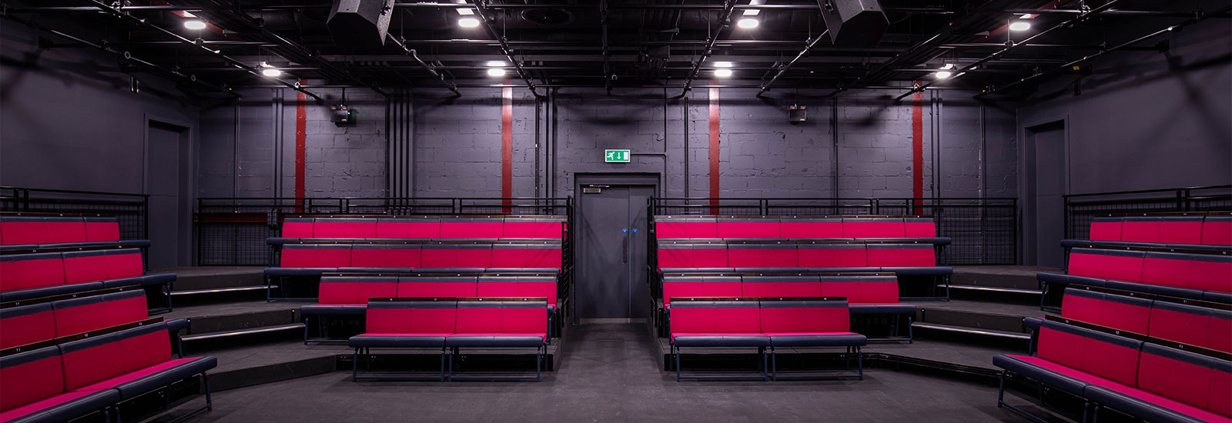
7, World’s End Place,
Chelsea, London SW10 0DR
Phone Number:0207 352 1967
E-mail:admin@chelseatheatre.org.uk

KEY CONTACTS
Paul Adlam, General Manager: paul@chelseatheatre.org.uk
Office: admin@chelseatheatre.org.uk
In-house technical person / consultant:

In the first instance please send all festival queries and tech riders to the General Manager.

Festival Call Out is for a single performance with full get in and get out on a single day.

ACCESS TO THE THEATRE
All access times must be confirmed with festival theatre staff before arrival. There are 1-2 parking spaces on site for loading and unloading only, with a direct load into the theatre via the theatre’s back entrance. Paid parking nearby. FOH theatre access is via the pedestrianised piazza at World’s End.
Accessible Access
The theatre has at least one fully accessible entrance on all sides. There is full accessibility to all areas of the centre and theatre excepting two of four entrances to the theatre from the wings, (See seating Plan A + B) the first floor direct exit from the theatre (See seating Plan C). There is a lift to the first floor and Accessible toilets on the first floor.

AUDITORIUM
Seated 120 capacity and will be set up in the round for the duration of the Festival (see photo above). Grid height is approximately: 270 CM

STAGE
The stage is a non-sprung lino floor with performance space of 5.854 m x 5.051m

Chelsea Theatre will provide a clean, bare performance area. The theatre has a black floor with dark grey walls and doors. There are backstage areas on both sides of the auditorium but no wings or side masking. Backstage cross-over may be possible through the bar access corridor depending on set up. Options for black back drop and black legs to create wings if required. Available in house

Entrances from the back and dressing room to the performance space are Front Stage Right or Front Stage left.

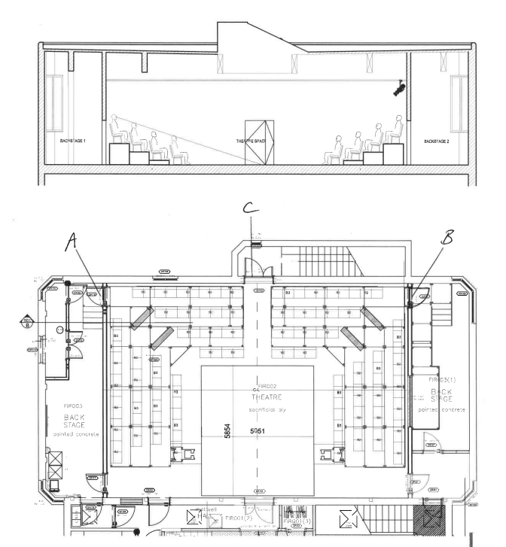

POWER
Four facility panels on the front wall of the theatre provide power at 400 & 240 V

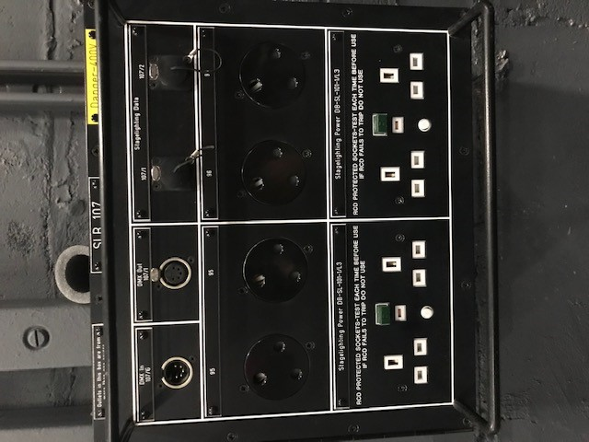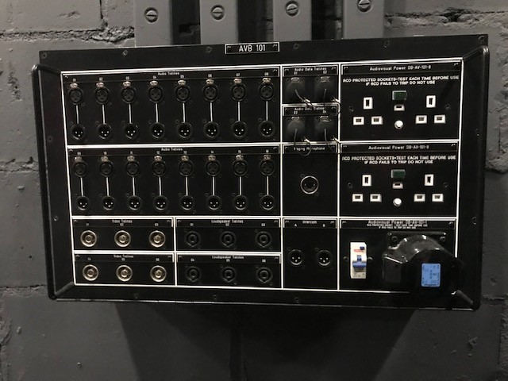

Small facility Panel X 3 Large Facility Panel X 1

SOUND
Detail TBC W/C 23th May 2021

LIGHTING
Detail TBC W/C 23th May 2021

Control Room
The auditorium control room is situated in the backstage area Stage left. The control room has a large window to the front, and direct access to the performance space. The studio control room is suitable for one or two operators only, as space is limited. The raised control platform is not accessible. The studio does not have a Stage Management desk. It does have show relay and comms system.

DRESSING ROOMS – update
The auditorium has two dressing rooms adjacent to SR door which can accommodate 10 people. The dressing room has mirrors, central hanging rail, 2 x Toilet and shower, one set accessible.

SAFETY
All sets used at The Chelsea Theatre must be either class 1 or fireproofed with a recognised brand of flame retardant. The theatre reserves the right if necessary, to refuse any item if we feel any Health and Safety regulations have been compromised. All electrical equipment bought into the theatre must have a valid PAT sticker on it. All risk assessments must be made available to the Chelsea Theatre / Festival Producer prior to or upon arrival so copies can be made and kept by ourselves.

************

